Jenkins installation steps
Use ubuntu servers for both master and slave.
1) Update the new server by running -- sudo apt update
2) install java -- sudo apt install openjdk-17-jdk -y
3) install wget – sudo apt install wget
3) Download the Jenkins package -- sudo wget -O /etc/apt/keyrings/jenkins-keyring.asc https://pkg.jenkins.io/debian-stable/jenkins.io-2023.key
4) Run this command -- echo "deb [signed-by=/etc/apt/keyrings/jenkins-keyring.asc]" https://pkg.jenkins.io/debian-stable binary/ | sudo tee /etc/apt/sources.list.d/jenkins.list > /dev/null
5) Once again update the server packages -- sudo apt-get update
6) Install Jenkins – sudo apt-get install Jenkins
7) Enable Jenkins as a service -- sudo systemctl enable Jenkins
8) Start Jenkins -- sudo systemctl start Jenkins
9) Check Jenkins running or not -- sudo systemctl status Jenkins

Jenkins master slave configuration
1) launch 2 servers in AWS console use same pem key for both and make sure you have installed the java (sudo apt install openjdk-17-jdk -y) on both slave servers
2) login to Jenkins UI got to settings > manage Jenkins > Nodes > New node you will get below pasted screen
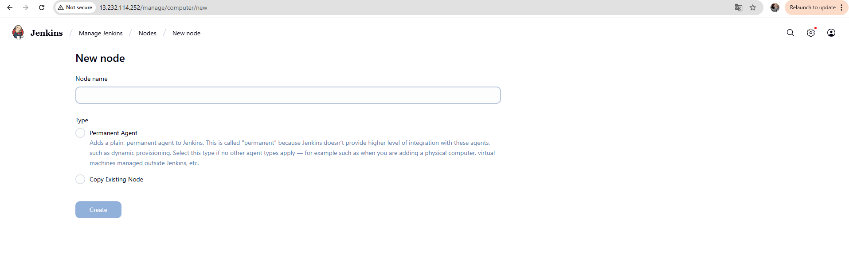
in above screenshot add node name and select permanent agent and click on create.

3) In next page select only required fields like remote root directory mention /home/ubuntu/ ref below screenshot
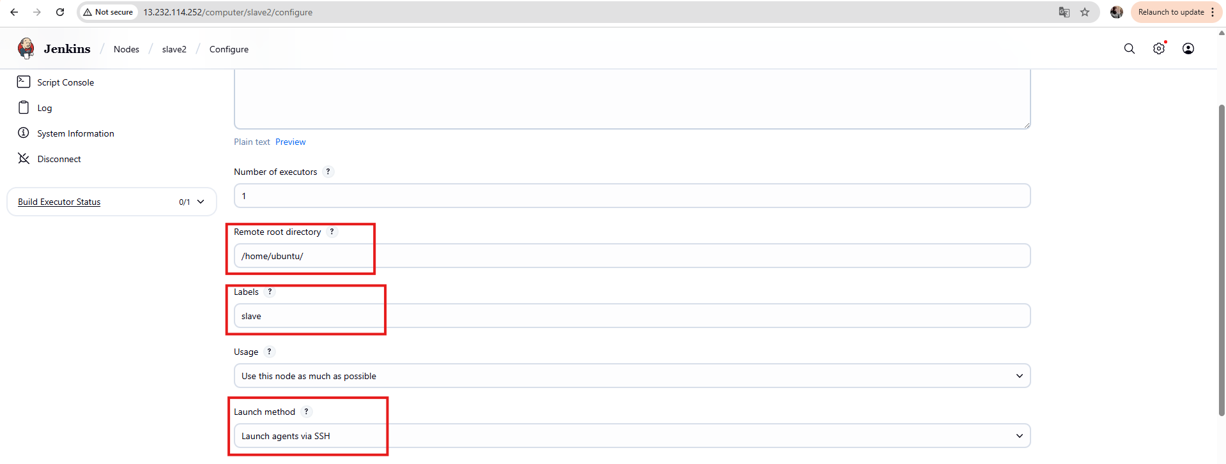

4) Here we are using the Launch method – Launch agent via SSH and under host name we need to give slave server private ip ref screenshot
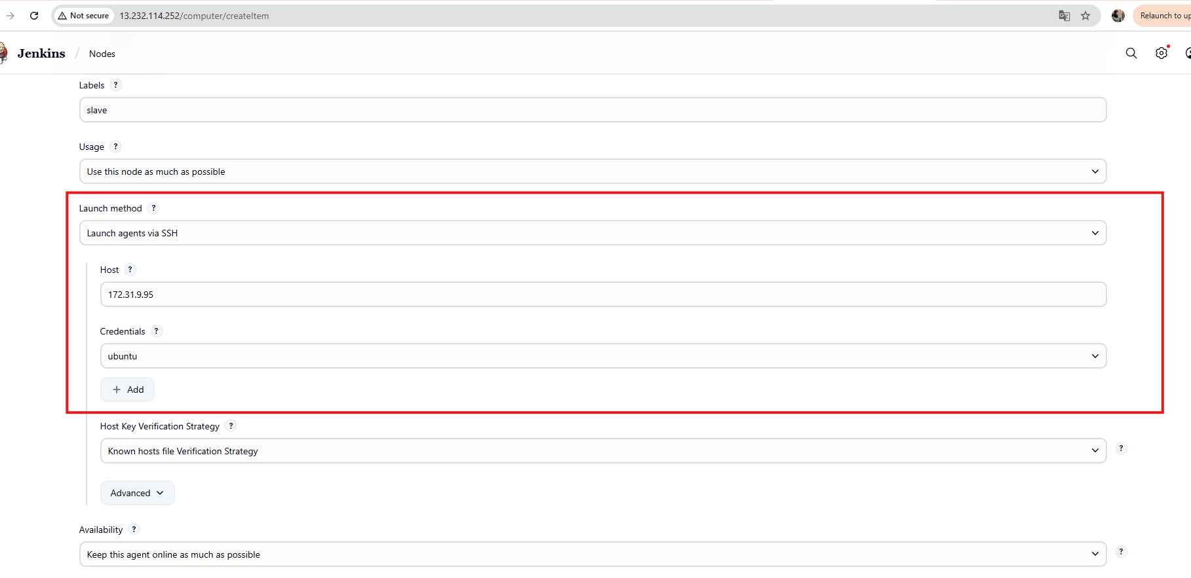

4) Adding credentials ref screen shot and under private key try to add pem file content as it is so that Jenkins master server will get access to slave servers.
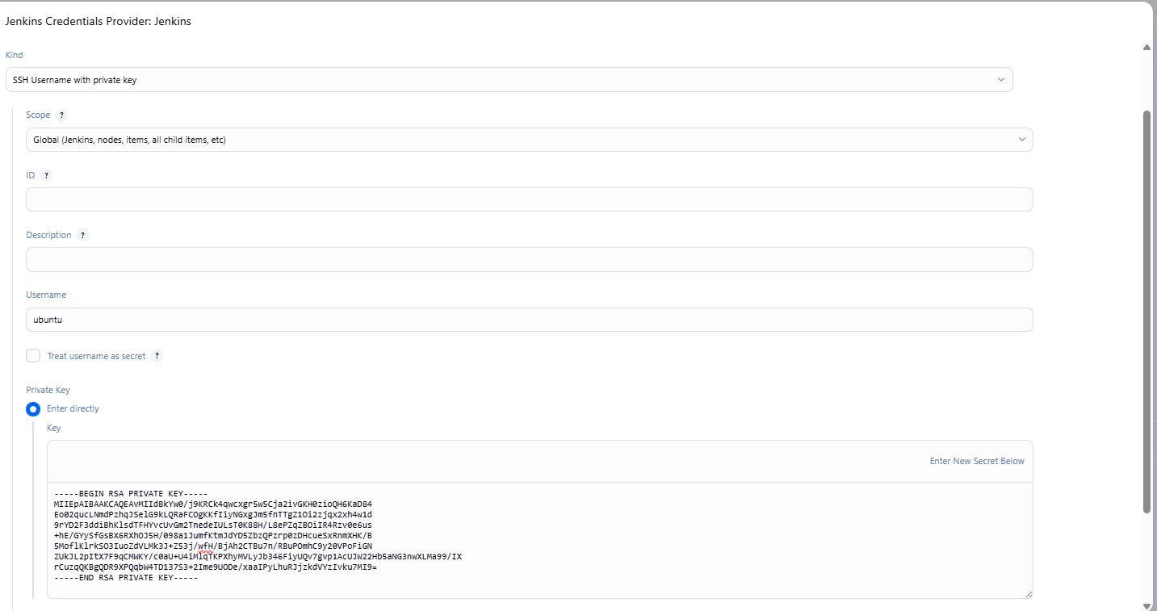

5) last step host key verification strategy select non verifying verification strategy ref screen shot 